Assignment 14.4 Ai Assisted Coding

Name : Karthikeya Uthuri

Htno:2303A51306
Btno:05
Task 1: Task 1: Responsive Homepage using HTML and CSS
Prompt: Generate a responsive homepage using HTML and CSS with a header, navigation menu, hero section, services section, and footer.
Use CSS media queries to make the layout responsive. Codes: index ,style css

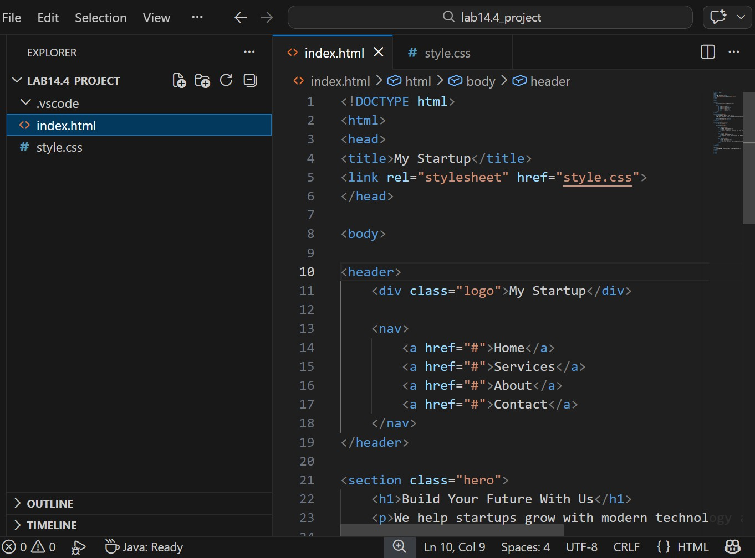

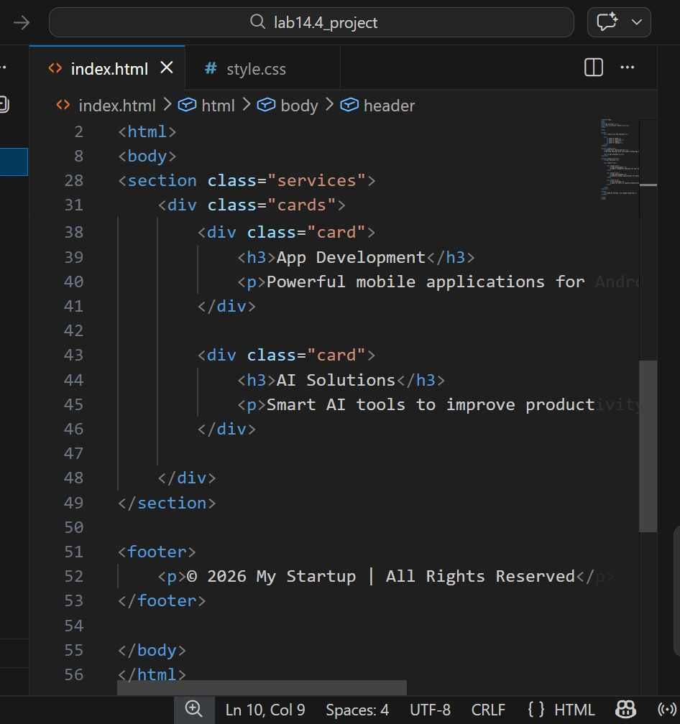
Style css:

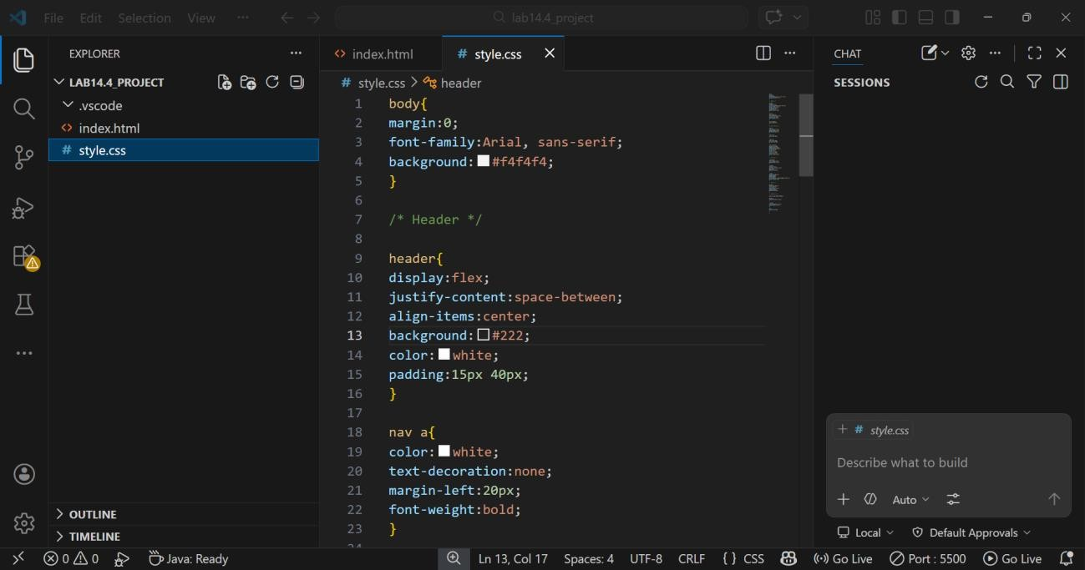

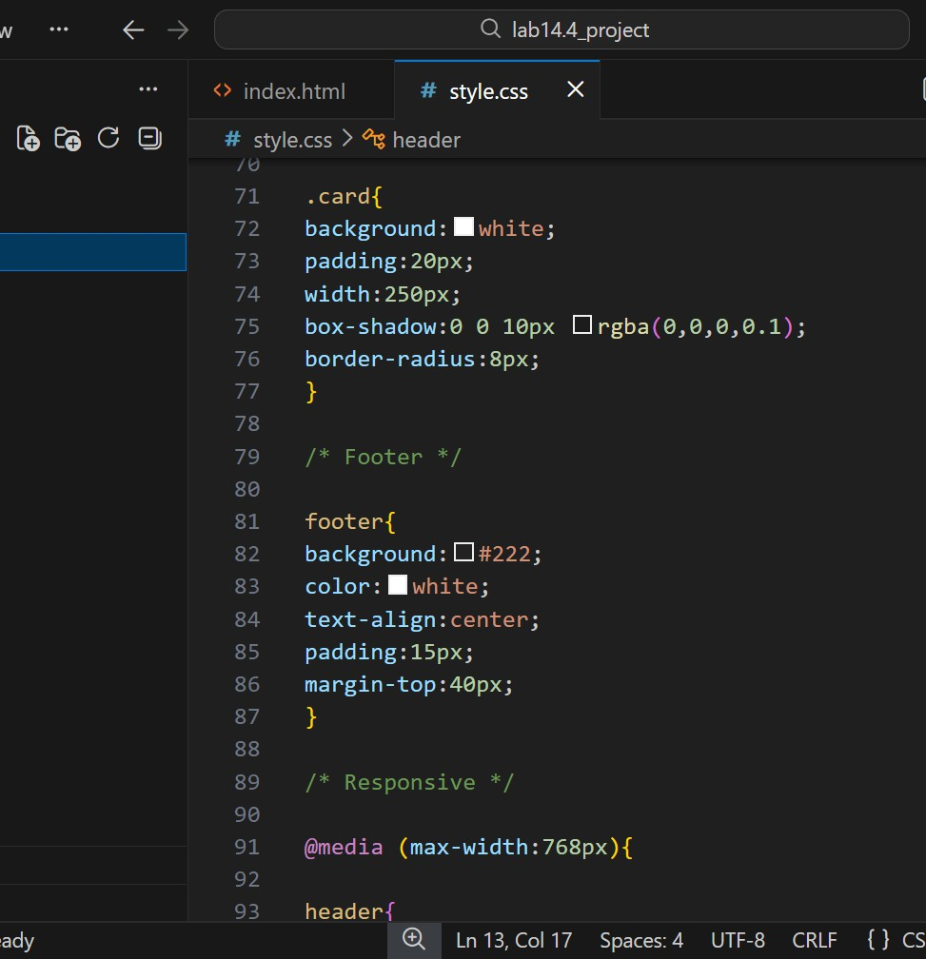
Output:

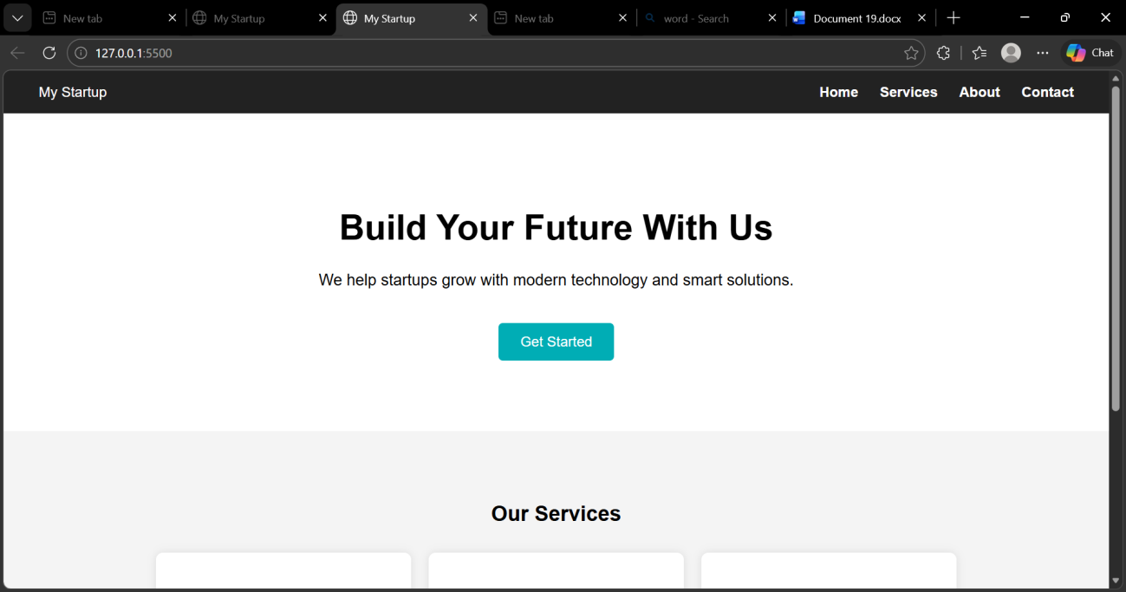
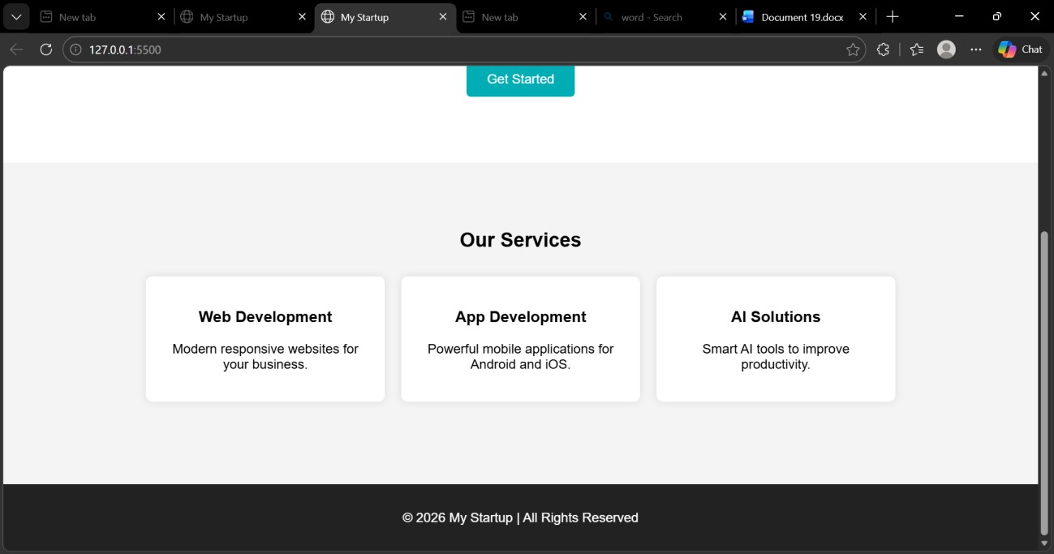

Explanation:
-->This task creates a responsive homepage using HTML and CSS.
-->The webpage contains a header with navigation links, a hero section,
-->service cards, and a footer. CSS is used for styling and media queries are used to make the webpage responsive for different screen sizes.

Task 2: Button Interaction using JavaScript

Prompt: Add a call-to-action button to the webpage.
When the user clicks the button, display an alert message using JavaScript without reloading the page.
Codes: index.html – edited part
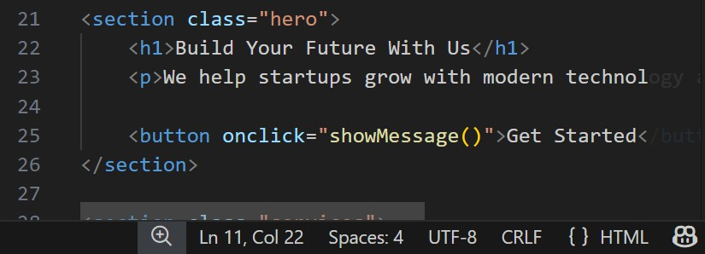
Java Script connection:


Add file :script.js

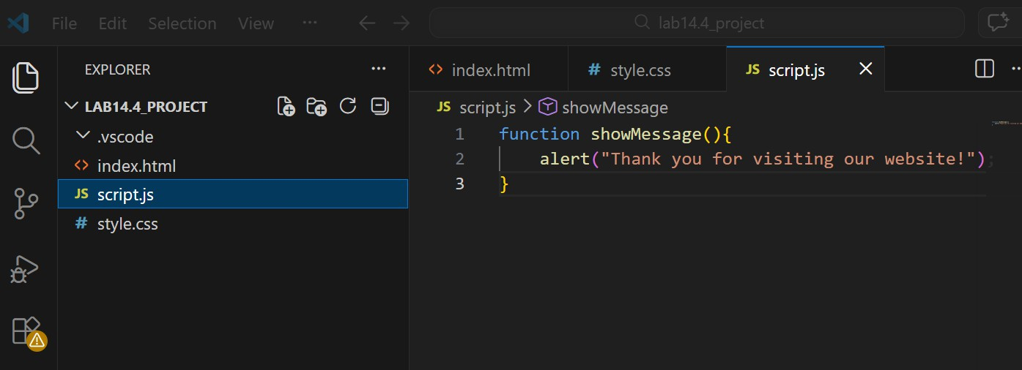
Output:

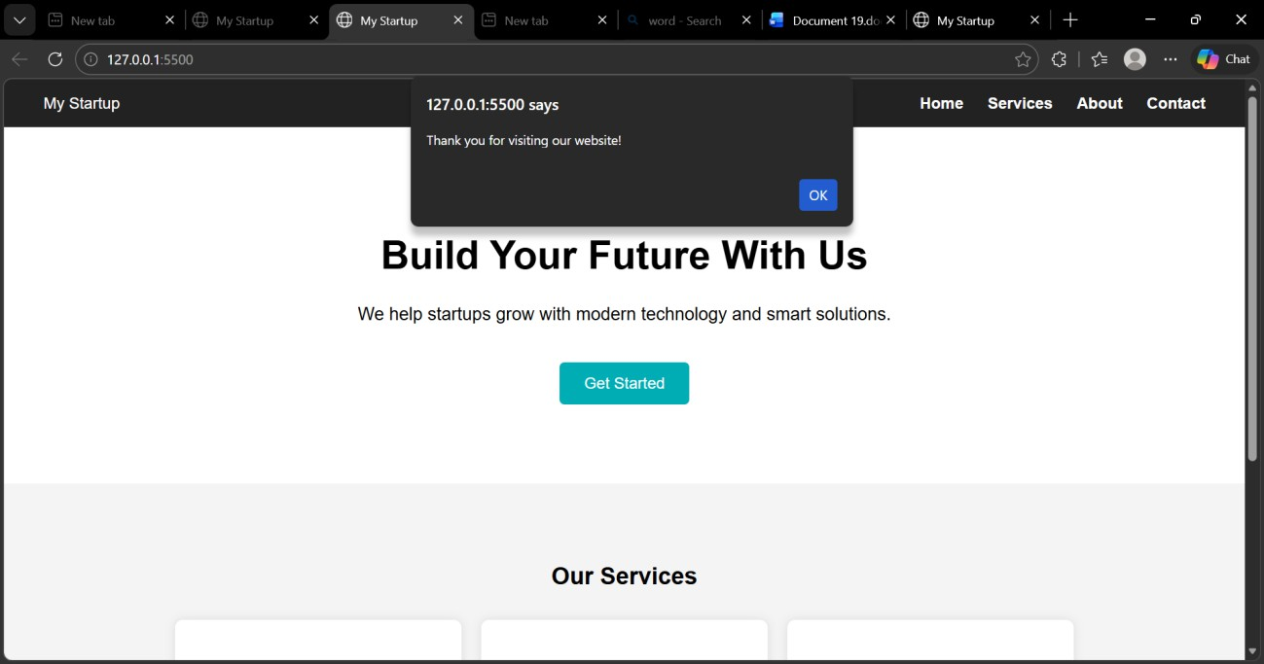

Explanation:
The button interaction is implemented using JavaScript.
When the user clicks the Get Started button, the showMessage() function is triggered and an alert message is displayed on the screen.

Task 3: Contact Form Validation using JavaScript
Prompt: Create a contact form using HTML with fields for Name, Email, and Message.
Use JavaScript to validate the form by checking empty fields and verifying the email format before submission.
Codes: index.html – Contact Form Section

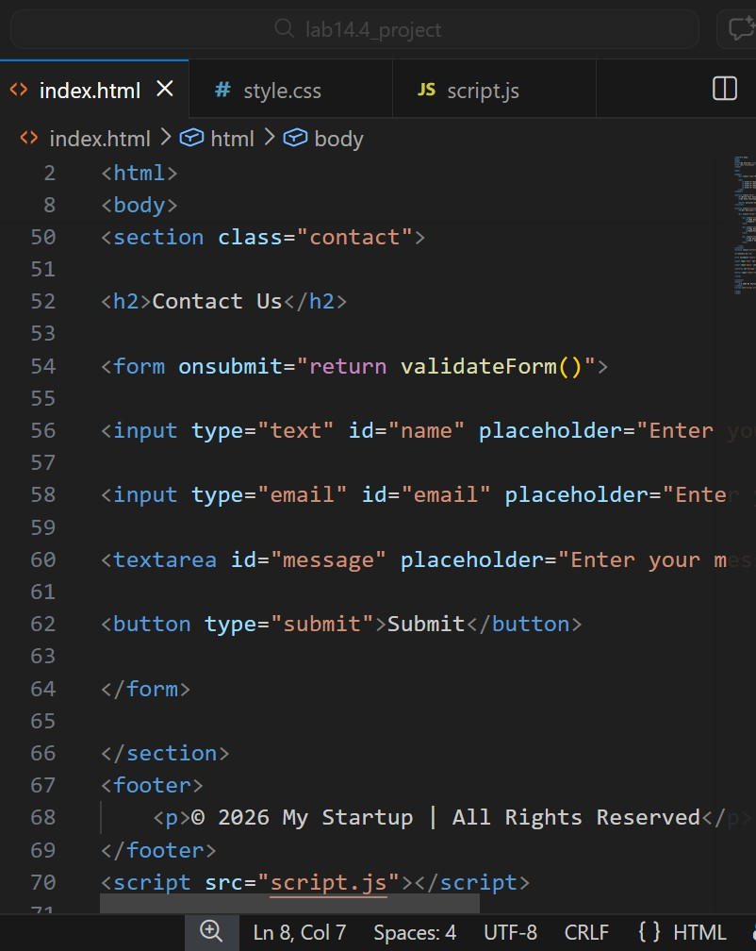

2)script.js – add below previous code:

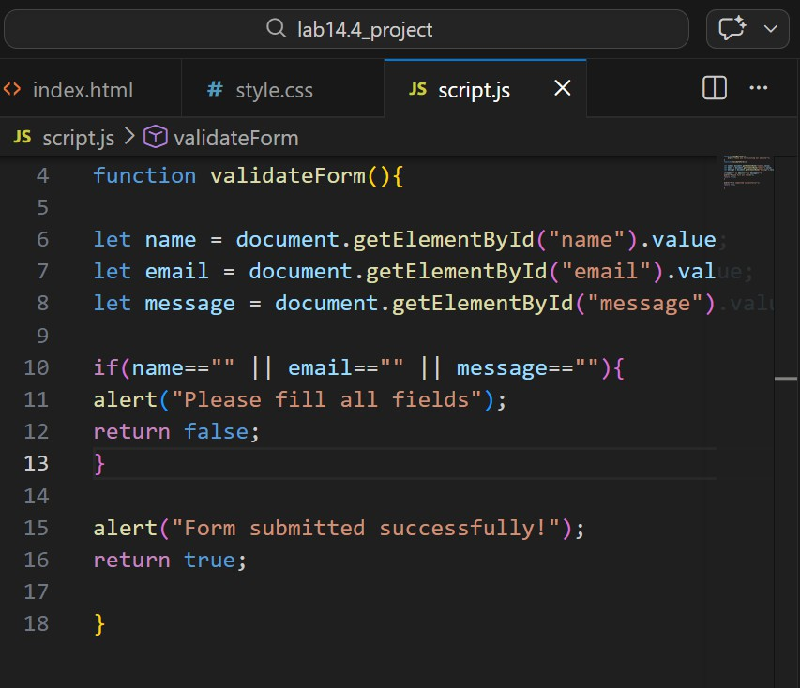
Output:

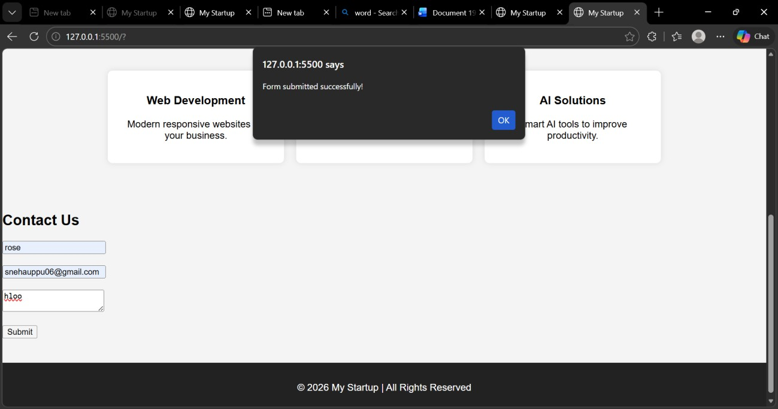

Expalantion:
This task creates a contact form with Name, Email, and Message fields.
JavaScript validation checks whether the fields are empty and displays an alert message before submitting the form.

Task 4: Dynamic Product List using JavaScript
Prompt: Create a dynamic product list where users can add new items and remove items from the list using JavaScript buttons.
Code:

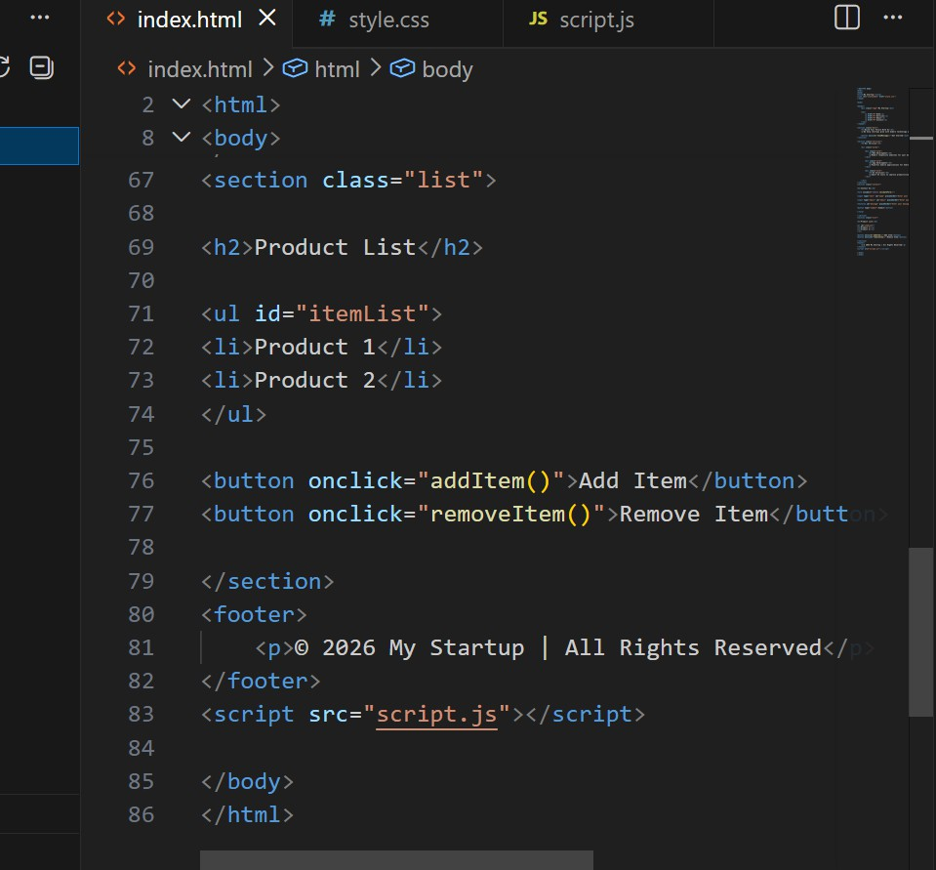

2)Java Script Add Item:

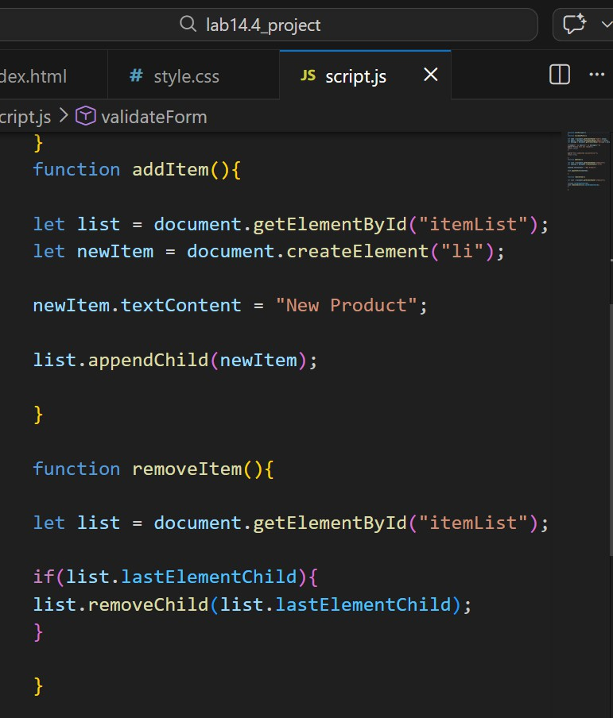
Output:

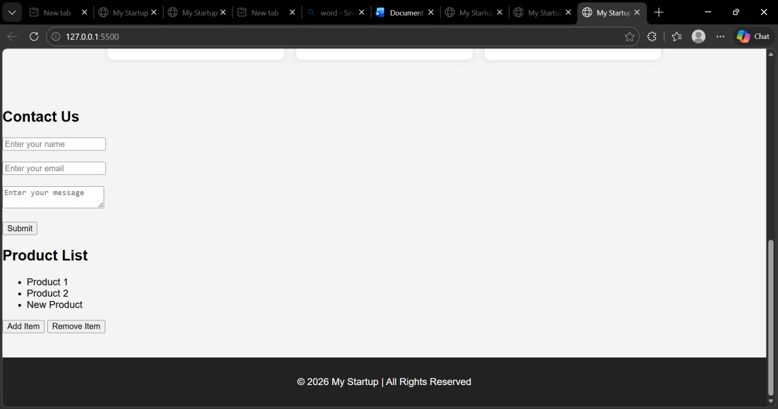

Explanation:
This program creates a dynamic product list where users can add or remove items using buttons. JavaScript DOM functions like createElement() and appendChild() are used to modify the list.

Task 5: Fetch Data using JavaScript API
Prompt: Create a webpage that fetches data from an API using JavaScript Fetch API and displays it on the webpage dynamically.
Codes: Index .Html

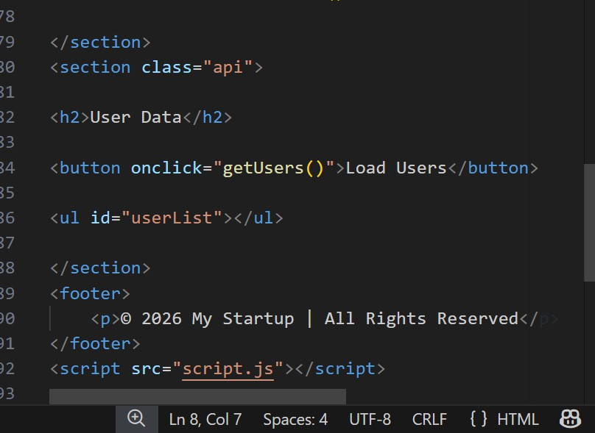
2)Java Script(Load Users):

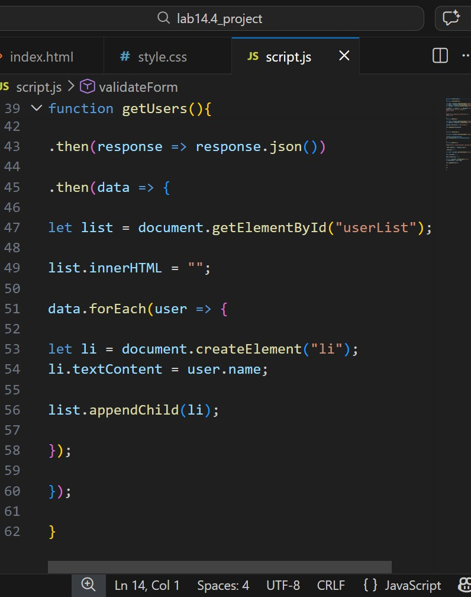
Output:

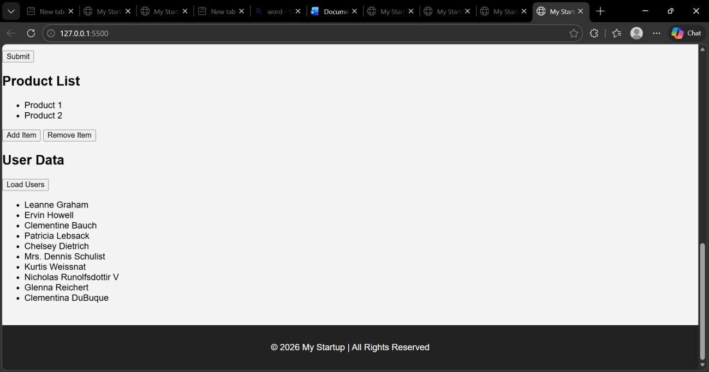

Explanation:
The Fetch API is used to retrieve user data from an external API. JavaScript dynamically creates list elements and displays the user names on the webpage. The JavaScript code processes this data and dynamically creates list elements to display the user names on the webpage. This allows the webpage to update content without reloading the page.

